**How to setup your own repo on Github**

<http://forum.mashupxbmc.com/showthread.php?372-How-to-setup-your-own-repo-on-Github>

**Step 1:** Create a [Github account](https://help.github.com/articles/signing-up-for-a-new-github-account) if you haven't yet.

**Step 2:** Create [your repo](https://help.github.com/articles/creating-a-new-repository) in your Github account.  
  
**Step 3:** Download and install [Github for Windows](http://github-windows.s3.amazonaws.com/GitHubSetup.exe).  
  
**Step 4:** Open Github for windows and enter username and password.  
Enter Full name and Email. Skip local repositories if you dont have any.  
  
**Step 5:** On the left side under github click on your username, on the right side your repository will show up.  
Right click on it and click clone.  
  
  
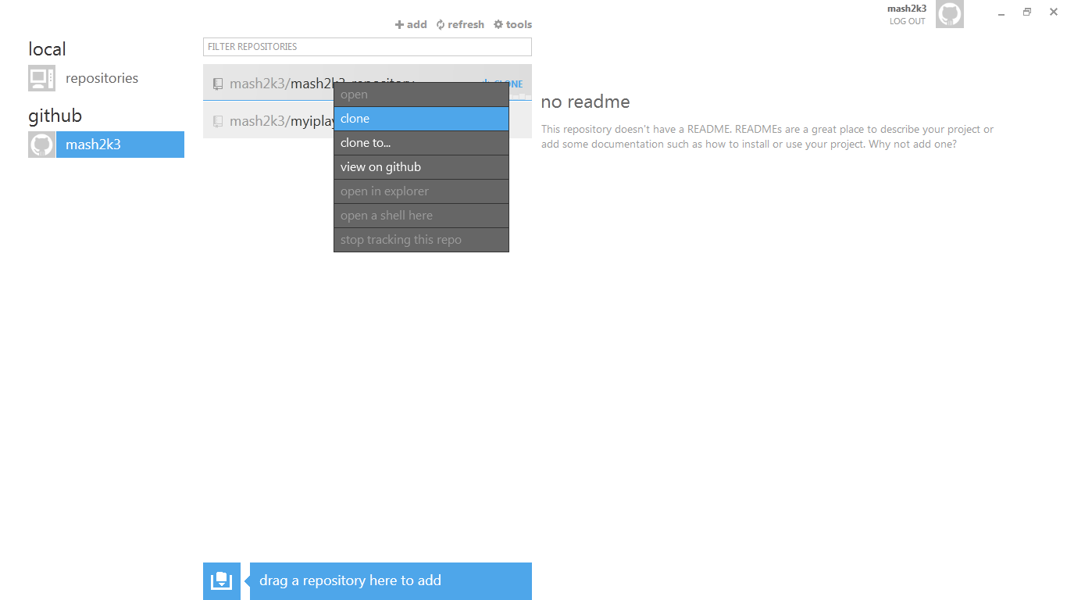

**Step 6:** Back to the left side under local click on repositories, on the right side your cloned repository will appear.  
Right click on it and click open in explorer.  
  
  
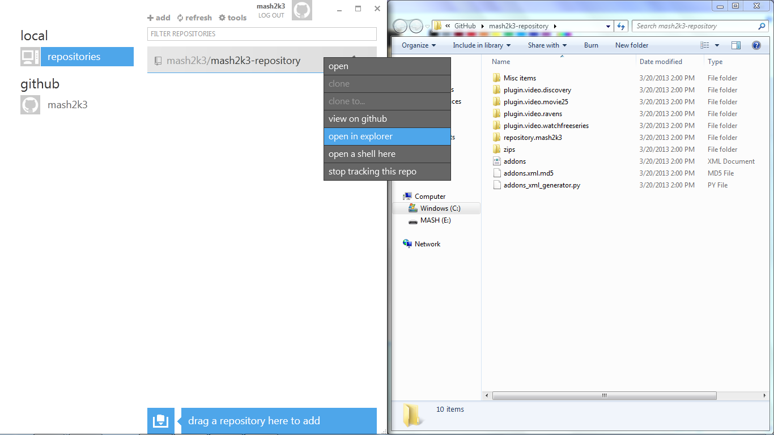  
  
  
**Step 7:** Now its time to setup your repo, what you need to do is [download this zip](https://dl.dropbox.com/u/35068738/Github/My-Repo.zip)  
and extract it in your Repo folder in your explorer  
so your directory will look like this Documents\GitHub\My-Repo\  
there is a readme.txt included follow instructions carefully   
obviously you will need to do simple editing of some files which is all in the readme  
  
**Step 8:** After completing the Instructions from the read me file, you must commit in order to push your changes   
to Github, to do that under repositories click on the blue arrow on the right of your cloned repository.  
Once repository is open you will find a yellow box to the right, fill in commit message (example "added repo") click commit then the blue sync at the very top.  
  
  
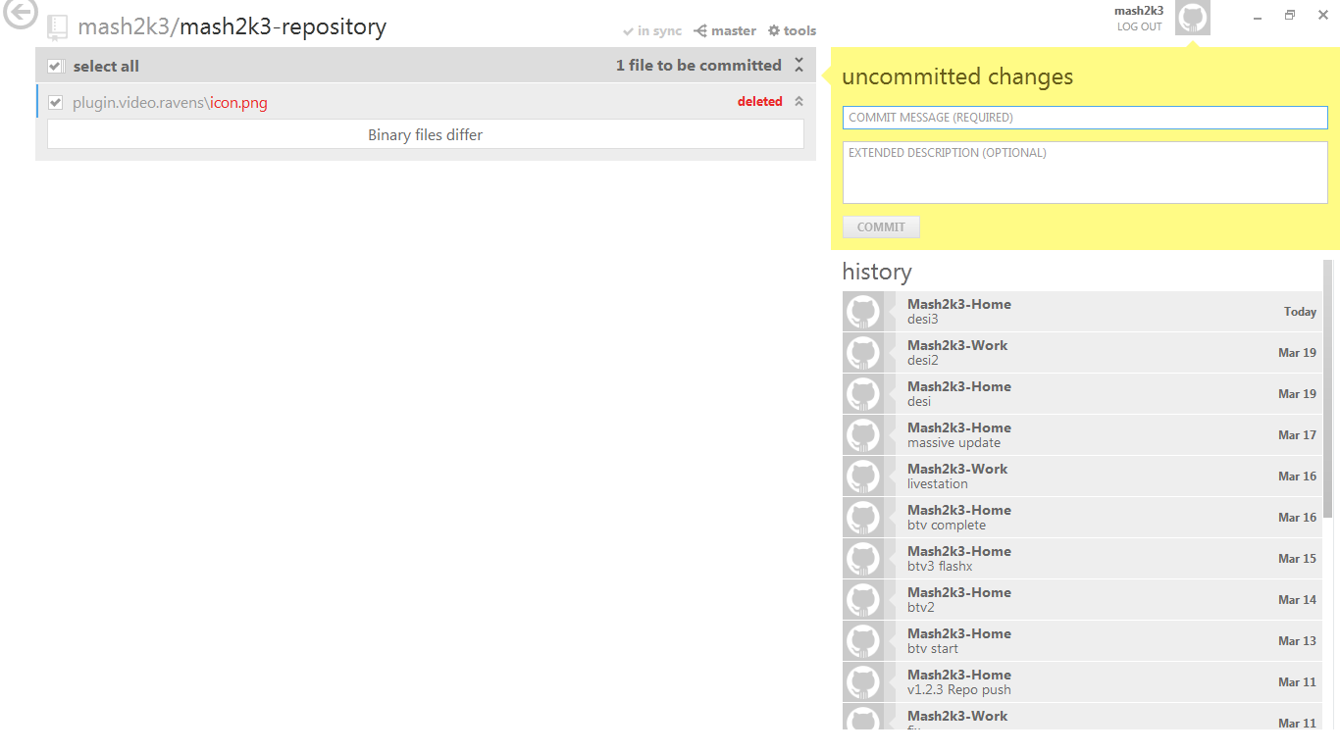  
  
  
**Step 9:** Provide your zipped Repo file for download, located here "https://github.com/CHANGEME/My-Repo/tree/master/zips" but to get the proper link you need, click on the zipped repo (repository.yourrepo.-1.0.zip) in the Github website. Then on the right side right click on raw and copy link location.   
  
  
